A1143-Afr-Egy-Amulet-Maahes-New Kingdom-19th-20th Dynasties-1292–1069 BCE-Blue Faience

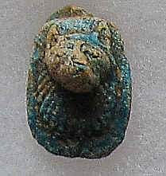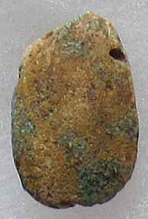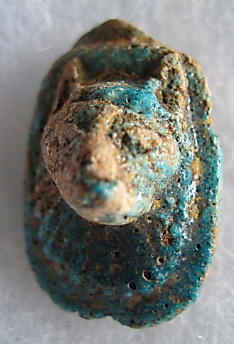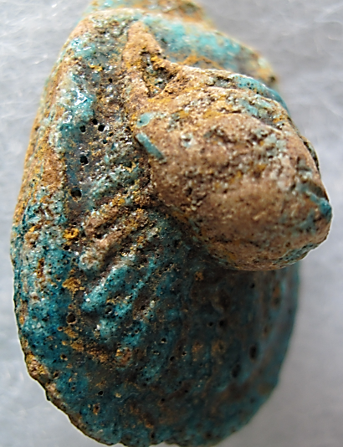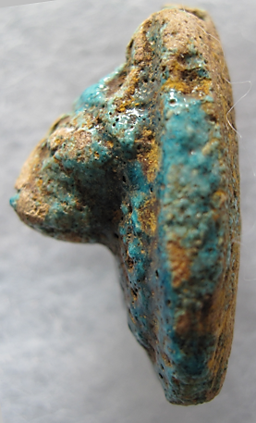

Figs. 1-5. Amulet-Maahes-New Kingdom-19-20th Dynasties-1292–1069 BCE-Blue Faience

**Case No.: 2**

**Display Description:** Maahes 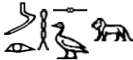 (Egyptian: Mahes, Maihes, Mios, Mihos; and Greek: Μαχές, Μάιχες, Μίος, Μιχός), was the son of the Creator God Ptah and the Feline Goddess either Bast in Lower Egypt or Sekhmet in Upper Egypt. In this amulet Maahes holds with his right hand over the left hand the *was* (*w3s*) scepter that shows the head and forked tail of the god Set, (i.e., Gardiner’s sign list: E20 , E21 , C7 , see Velde 1967), that implies “chaos” and “violence”. Accordingly, Maahes is both the violent, war-like Lord of Slaughter, Wielder of the Knife, against those who violate the universal order of Ma’at, and the stalwart protector of the innocent (Lurker 1987: 215). He wears a striated wig terminated by single horizontal bands. The entire amulet was once covered with a whitewash of kaolin clay.

**Accession Number: A1143**

**LC Classification:** DT62

**Date or Time Horizon:** 19th-20th Dynasties-1292–1069 BCE

**Geographical Area: Leontopolis**

**Map, GPS Coordinates:** 30.12933 31.30753; 40° 26' 46" N 79° 58' 56" W

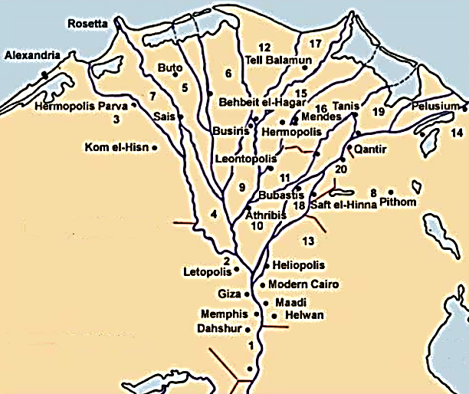

Fig. 4. Map of Lower Egypt showing relative location of  Aakhennu (Greek: Leontopolis). After https://upload.wikimedia.org/wikipedia/commons/7/79/GD-EG-Nomes_de_Basse-%C3%89gypte.jpg



Fig. 5. Map of Nay-ta-hu (Greek: Leontopolis). After Petrie.

**Cultural Affiliation:** 19-20th Dynasties-1292–1069 BCE

**Medium:** Blue faience.

**Dimensions: H 32.05 mm, 1.26 in.  
Weight: 6 gm; 1/8 oz.**

**Provenance: Old European Collection.**

**Condition:** Original.

**Discussion:** TheMaahes cult was located in the 23rd dynasty’s capital Nay-ta-hut (Leonto-polis (Λεόντων πόλις, the “Polis of Lions”) that also honored the leonine goddesses Bast and Sekhmet, where, in Ptolemaic times, lions roamed freely and were satiated daily with slain oxen according to the Roman historiographer Aelian. Josephus tells us twice, once in his *Antiquities of the Jews*, Book XIII, Chapter III, and again in his *Wars of the Jews*, Book VII, Chapter X, that, when Jonathan, the Maccabee, was made high priest of the Jews, about 153 BCE, Onias, the son of Onias III, the deposed high priest, went to Egypt and obtained a grant of land for a Jewish temple in the region of the city of Bubastis called by the Greeks Leontopolis, the nome where Bast, Sekhmet and Maahes were worshipped (Naville, Tylor and Griffith. 1894). Since Maahes was also associated with the Nubian Lion God Apedemak, he was honored in Upper Egypt at the temple of Isis in Dabod, Nubia (a monument that has been since relocated and restructured in Madrid, Spain).

. 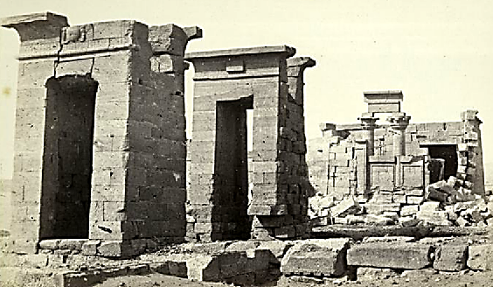

Temple of Isis where Maahes was also worshipped in Dabod, Nubia, photographed by Francis Frith in 1862 (https://images.nypl.org/index.php?id=76467&t=w), 15 km (9.3 mi) south of Aswan (Arnold, Strudwick and Gardiner 2003: 64)near the first cataract of the Nile.

**References:**

Arnold, Dieter, Nigel Strudwick and Sabine Gardiner. 2003. *The Encyclopaedia of Ancient Egyptian Architecture*. London: I.B. Tauris Publishers.

Lurker, Manfred. 1987. Dictionary of Gods and Goddesses, Devils and Demons. London: Routledge.

Naville, Edouard, J. J. Tylor and F. L. Griffith. 1894. *Ahnas el Medineh (Heracleopolis Magna) : with chapters on Mendes, the nome of Thoth, and Leontopolis.* Memoirs of the Egypt Exploration Fund, 11. London: The Egypt Exploration Fund.

Velde, H. te. 1967. *Seth, God of Confusion: A Study of His Role in Egyptian Mythology and Religion*, Probleme der Ägyptologie, 6 , G. E. van Baaren-Pape, transl. W. Helck. Leiden: Brill.